A Sample for NICOGRAPH
Taro Geijutsu-Kagaku Jiro Geijutsu-Kagaku
The University for Art and Science
{taro, jiro} (at) art-science.ac.jp

Abstract
This paper presents the Microsoft WORD version of a sample for NICOGRAPH.

1. Introduction
This document is a sample for NICOGRAPH International. We provide two formats of the sample: for MS WORD and LaTeX.

2. Format

2.1 Page setting
Please set the size of pages as "A4", not "Letter". Number of pages is limited as follows:
[Full paper:] to be accepted with as few as 4 pages and as many as 12 pages.
[Short paper:] max length 4 pages.
[Poster:] max length 2 pages.

2.2 Contents
Please indicate the following information in the beginning of the paper, as this sample indicates:
- Title
- Author names
- Author affiliations
- Contact e-mail addresses
- Abstract
Then please describe the following contents as the body of the paper in two-column format.
- Body text
- References
- Figures and tables
By the way, the review process of NICOGRAPH is not double-blind. Therefore, please do not delete author information on the review paper.

3. Detailed specifications

3.1 Header and footer
This sample sets the header to indicate the name of conference, and the footer to indicate the page numbers. Authors do not need to care them, because they will be edited by publication chairs.

3.2 Section
It is strongly recommended to divide the body text into several sections. It is needed to manually make section numbers to every section titles while using MS WORD.

3.3 Figures and tables
It is required to indicate titles of all figures and tables with their sequential numbers. Also, it is required to refer all figures and tables from body text with the numbers.
Titles of figures must be inserted at the BOTTOM of the figures themselves, as shown in Figure 1.

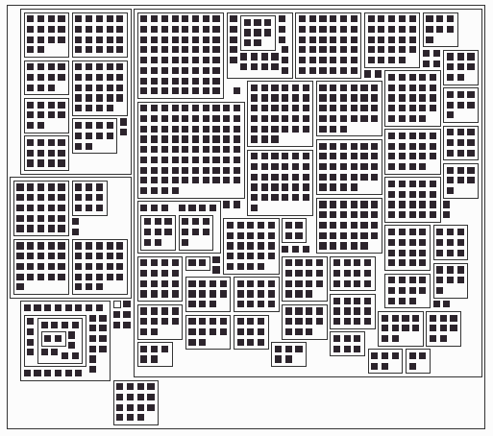
Figure 1. Example of figure (copied from [1]).

Titles of tables must be inserted at the TOP of the tables themselves, as shown in Table 1.

Table 1. Example of table
 | Math | English | Japanese
Taro | 68 | 91 | 34
Jiro | 53 | 12 | 97

3.4 References
Please list all the cited references at the end of the body text. It is required to indicated sequential numbers of all the references, and cite them from the body text. An example is shown in the section of the references in this sample. It is recommended to describe author names, title, name of magazines or conferences, page numbers, and issued year. Publisher and ISBN number are also useful information. The above information is not required while citing non-document references such as Web pages.

3.5 Fonts
Following fonts are recommended.
Title: Arial or similar fonts in 14 to 16 points. Centering is strongly desirable.
Author names: Arial or similar fonts in 12 to 14 points. Centering is strongly desirable.
Author affiliations: Arial or similar fonts in 11 to 12 points. Centering is strongly desirable.
Contact e-mail addresses: Arial or similar fonts in 10 to 11 points. Centering is strongly desirable.
Abstract: Times New Roman or similar fonts in 9 points. Justification is strongly desirable.
Section title: Arial or similar fonts larger than 9 points. In this sample file, section titles are in 12 points, subsection titles are in 10.5 points, and sub-subsections titles are in 10 points.
Body text: Times New Roman or similar fonts in 9 points. Similar fonts are recommended to references, and figure/table titles. Justification is strongly desirable.

3.6 Equations
Equation editor is strongly recommended to use while using MS WORD. It is recommended to indicate sequential numbers to important equations, and cite them with the numbers.

4. Conclusion
This sample file described formats and detailed rules of the papers for NICOGRAPH International. We appreciate if you kindly report any troubles or inconveniences of this sample.

References
[1] T. Itoh, Y. Yamaguchi, Y. Ikehata, Y. Kajinaga, Hierarchical Data Visualization Using a Fast Rectangle-Packing Algorithm, IEEE Transactions on Visualization and Computer Graphics, Vol. 10, No. 3, pp. 302-313, 2004.

