Template for the Journal of the Society for Art and Science
John Art¹⁾ (Student Member) William Science²⁾ (Member)
1) Graduate School of Art and Science, The University for Art and Science
2) Department of Art and Science, The University for Art and Science
{john_a, bill_s} at art-science.ac.jp

Abstract
This paper presents the Microsoft WORD version of a sample for the Journal of the Society for Art and Science.

1. Introduction
This document provides the Microsoft Word version of a sample for the Journal of the Society for Art and Science. The author should also refer to “guidelines for submission” at the following URL (Japanese):
http://www.art-science.org/journal/guide2.html

2. Paper format

2.1 Paper size and page limit
The paper size should be A4. If the authors include any content which exceeds this page size, please refrain from including the content in the paper and submit it in a separate file instead.
There is no limitation on the number of pages. The paper is categorized as follows:
- Paper less than 1,500 words are treated as short papers. Beyond that, papers are treated as full papers.
- Full papers longer than 9,000 words are not prescribed. Papers exceeding this amount may be accepted by moving the excess content into separate files such as appendices or supplemental materials.

2.2 Paper structure
The title page should include:
- Paper title
- Author name(s)
- Author affiliation(s)
- Contact information (optional)
- Abstract

Manuscripts should be written in 2 columns and include:
- Paper Body
- References
- Figures and tables
- Biographical summary of the author(s)

This journal does not use double-blind review. Please do not omit the author name(s) and affiliation(s) in the manuscript.

3. Remarks

3.1 Header and footer
This sample document includes a header indicating the name of the journal, volume number, issue number, and pages. The document also includes a footer which shows the page number. The editor of the journal will edit the header and footer, so the authors do not have to edit these items. However the editor may ask the authors to modify the header or footer.

3.2 Chapter
The paper body should be divided into appropriate chapters. Each chapter title should include a number, except for the Acknowledgements and References. When writing a paper in Microsoft Word, it is advisable to make style presets to save time.

3.3 Figures and tables
All figures and tables are to be numbered using Arabic numerals. Figures and tables should always be cited in text and placed near the citation. Each figure and table should be given a caption with a number and title.
In Microsoft Word, the Insert function may be used to insert figures at arbitrary locations. These figures must include a title and number placed below the body of the figure. This is shown in the following example.
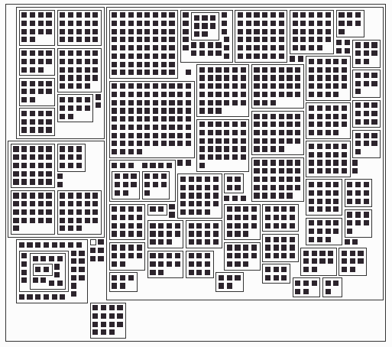
Figure 1. Sample Figure

Tables may also be inserted using the Insert function. Tables must include a title and number as well. This is shown in the example below.
Table 1. Sample Table．
 | Math | Physics | Design
John | 68 | 91 | 34
Williams | 53 | 12 | 97

3.4 Reference
References are to be listed at the end of the paper. All references should be cited somewhere in text and numbered with Arabic numerals. There is no limitation on the number of references. The authors are recommended to list enough references to argue their originality. In particular, do not neglect to list the authors’ own related works.
A sample reference [1] is listed at the end of this document. A reference should include the names of authors, paper title, journal name, volume number, issue number, page numbers, and issue year. Please include the publisher and ISBN for books if available. All other references, such as websites, are exceptions.

3.5 Biographical summary
A biographical summary for each author should be written in less than 100 words following the References. Each summary should include the author’s name, academic degree(s) with issuing institution, year of completion, job history, research field, affiliated academic societies, and so on. The author’s photo is also to be included.

3.6 Font and paragraph settings
It is advisable to set up fonts and paragraphs as described below.

3.6.1 Title page
Paper Title: 14-16 points, Arial or similar font families are recommended. The title should be center-aligned.
Author Name: 12-14 points, Arial or similar font families are recommended. The name should be center-aligned.
Author Affiliation: 11-12 points, Arial or similar font families are recommended. The affiliation should be center-aligned.
Author Contact Information: 10-11 points, Arial or similar font families are recommended. Contact information should be center-aligned. Note that the authors should guard against spam mail if they intend to include their e-mail addresses in their contact information. This sample uses “at” instead of “@” for the e-mail address.
Abstract: 9 points, Times New Roman or other similar font family is recommended．The text alignment should be justified.

3.6.2 Chapters, body and others
Chapter titles: Use a bigger font size than in the body text, and a different font family. This sample uses 12 points for Chapter 3, 10.5 points for Section 3.6, and 10 points for Sub-Section 3.6.2, respectively. It is advisable to use Arial or a similar font family. The title should be center-aligned.
Body and others: 9 points, Times New Roman or similar font family. The text alignment should be justified. Others, such as figure captions, references, and biographies should be formatted in the same manner. Figure captions and table captions can be center-aligned.

3.7 Equation
It is advisable to use Microsoft Math Editor to write an equation in Microsoft Word. All equations are to be numbered using Arabic numerals and cited in the text.

4. Conclusion
This document has provided the Microsoft Word sample version of a paper for the Journal of the Society for Art and Science．We would appreciate it if you could inform us of any discrepancies or difficulties in using this document.

Reference
[1] T. Itoh, Y. Yamaguchi, Y. Ikehata, Y. Kajinaga, Hierarchical Data Visualization Using a Fast Rectangle-Packing Algorithm, IEEE Transactions on Visualization and Computer Graphics, Vol. 10, No. 3, pp. 302-313, 2004.
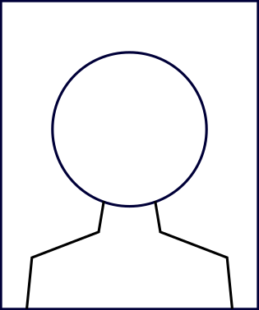
John Art received his B.S. in Information Technology and M.S. in Computer Science from Hogehoge University, Japan, in 1990 and 1992. He is currently a Ph.D. candidate at the School of Art and Science, in the University of Art and Science. His research interests include scientific visualization and music information processing. He is a member of ACM, IEEE Computer Society, and the Society of Art and Science.

William Science has been a Professor in the Department of Art and Science, at the University of Art and Science since 2014. He received his B.S. in Information Technology and M.S in Computer Science from Hogehoge University, Japan, in 1990 and 1992. His research interests include scientific visualization and music information processing. He is a member of ACM, IEEE Computer Society, and the Society of Art and Science.

